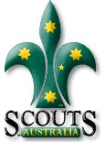
You’re coming to….
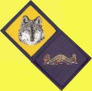
Gold Camp III!

Rowallan Scout Camp
Riddells Creek
9am – 5pm, Sat 31st March, 2012

Welcome to Gold Camp III! It’s a fantastic camp only for older Cubs, for this year compressed into one day – you’ll learn more about how to go out and earn your Grey Wolf Award, cook some food and have FUN! You’ll be meeting with Cubs and Leaders from around Melbourne and Victoria.

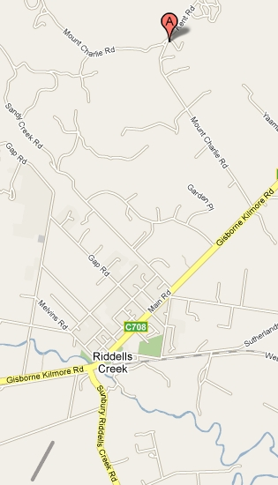
Location: Rowallan Scout Camp, Kent Rd, Riddells Creek, Vic
About it: We’ll learning about Grey Wolf Activities (including a hike), eating food which you CUBS will cook! and will have tons of fun while we learn some great stuff. We’ll be right next to the Pack Holiday Centre, with toilet facilities and full shelter if the weather gets too rough.
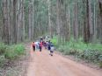
Doing? The Grey Wolf is the highest award in Cubs and has to be done by the Cubs themselves… this day aims to help you learn what to do and experiment for yourself – even going on a 2 hour practice hike! – so you can go home and be more confident in earning your Grey Wolf. ALSO you’ll try some Scout stuff – like cooking in Patrols and more! Don’t miss it!
Leaders: Leaders from all Packs attending
- Leader/Cub ratios will be easily met.
Take: - Dilly Bag with plastic or melamine plates & cup + cutlery
- Wear Cub uniform, hiking shoes/good socks, Hat, sunglasses, sunscreen (waterproof coat if needed)
WATER BOTTLE, not leaking, full of water!
Personal first aid kit if you have one, bandaids for if you get a blister!
Back Pack for the hike, to take your water, sunscreen, first aid and supplied snacks
COST: $15 per Cub – pay to your Leader
Contact: Your contact at the camp will be your attending Cub Leader

